Experiment – 2.3.1
Student Name: Himanshu Goyal | UID: 24BDA70369
Branch: CSE (Data Science) | Section/Group: 24 BDS-4(B)
Course: Full Stack II (24CSP-337) | Date of Performance: 23-09-2026

1. Aim:
To implement secure backend APIs using JWT authentication and role-based authorization.
2. Software Required:
• Programming Language: Java (JDK 17 or higher)
• Framework: Spring Boot with Spring Security (spring-boot-starter-security)
• JWT Library: JJWT (io.jsonwebtoken: jjwt-api, jjwt-impl, jjwt-jackson)
• IDE / Environment: Visual Studio Code with Java Extension Pack / IntelliJ IDEA
• API Testing Tool: Postman / Windows PowerShell Invoke-RestMethod
3. Objectives:
• To understand JWT-based authentication: stateless Bearer token issuance, HMAC-SHA256 signature verification.
• To configure Spring Security for API protection: disabling CSRF, enforcing STATELESS session policy, securing endpoints.
• To implement authentication filters: custom OncePerRequestFilter parsing Authorization header and populating SecurityContext.
• To enforce role-based access control (RBAC): using method security @PreAuthorize('hasRole("ADMIN")').
• Course Outcomes Mapped: CO2 - BT2, CO3 - BT3, CO4 - BT4
4. Theory:
Modern cloud-native backends require stateless authentication to achieve effortless horizontal scalability. Traditional session-based authentication stores user session state in server memory, requiring sticky sessions or distributed session caches. JSON Web Tokens (JWT) eliminate this overhead by packaging user identity, assigned roles, and expiration timestamps into a self-contained, cryptographically signed token. The client passes this token in the 'Authorization: Bearer <token>' header on every API invocation.
Spring Security intercepts all incoming requests through a customizable SecurityFilterChain. By declaring SessionCreationPolicy.STATELESS, the server never creates HTTP sessions. A custom JwtAuthenticationFilter (extending OncePerRequestFilter) extracts the Bearer token, validates its HMAC-SHA256 cryptographic signature against a secure 256-bit secret key, and constructs a UsernamePasswordAuthenticationToken populated with GrantedAuthority roles (e.g., 'ROLE_USER', 'ROLE_ADMIN').
Role-Based Access Control (RBAC) restricts access to sensitive operations based on the caller's verified authorities. Method-level security enabled by @EnableMethodSecurity allows declarative annotations such as @PreAuthorize("hasRole('ADMIN')"). If an unauthenticated user attempts access, Spring Security returns 401 Unauthorized; if an authenticated user with ROLE_USER attempts an ADMIN operation, it returns 403 Forbidden with a standardized ApiErrorResponse envelope.
5. Procedure / Algorithm:
• Step 1: Add spring-boot-starter-security and jjwt dependencies to pom.xml.
• Step 2: Define User entity with UserRole enum ('ROLE_USER', 'ROLE_ADMIN') and BCrypt password encryption.
• Step 3: Implement JwtService to generate, sign, and validate HMAC-SHA256 tokens with configurable expiration (e.g., 15 minutes).
• Step 4: Develop JwtAuthenticationFilter extending OncePerRequestFilter to intercept requests and populate SecurityContextHolder.
• Step 5: Configure SecurityConfig bean disabling CSRF, configuring CORS, and registering JwtAuthenticationFilter before UsernamePasswordAuthenticationFilter.
• Step 6: Enable method security with @EnableMethodSecurity(prePostEnabled = true).
• Step 7: Develop AuthController with /register, /login, and /me endpoints returning standardized AuthResponse tokens.
• Step 8: Develop AdminController annotated with @PreAuthorize("hasRole('ADMIN')") for dashboard and purge endpoints.
• Step 9: Verify 401 Unauthorized and 403 Forbidden enforcement using 6 automated integration tests in SecurityAndJwtIntegrationTest.
6. Code and Output:
Listing 1: Stateless Security Filter Chain & RBAC Configuration (SecurityConfig)
@Configuration
@EnableWebSecurity
@EnableMethodSecurity(prePostEnabled = true)
public class SecurityConfig {
private final JwtAuthenticationFilter jwtAuthFilter;
private final CustomAuthenticationEntryPoint authenticationEntryPoint;
private final CustomAccessDeniedHandler accessDeniedHandler;
@Bean
public SecurityFilterChain securityFilterChain(HttpSecurity http) throws Exception {
return http
.csrf(AbstractHttpConfigurer::disable)
.cors(Customizer.withDefaults())
.sessionManagement(s -> s.sessionCreationPolicy(SessionCreationPolicy.STATELESS))
.authorizeHttpRequests(auth -> auth
.requestMatchers("/api/v1/auth/**", "/h2-console/**").permitAll()
.requestMatchers(HttpMethod.GET, "/api/v1/posts/**").permitAll()
.requestMatchers("/api/v1/admin/**").hasRole("ADMIN")
.anyRequest().authenticated()
)
.exceptionHandling(ex -> ex
.authenticationEntryPoint(authenticationEntryPoint)
.accessDeniedHandler(accessDeniedHandler)
)
.addFilterBefore(jwtAuthFilter, UsernamePasswordAuthenticationFilter.class)
.build();
}
}

Listing 2: Cryptographic JWT Service (HMAC-SHA256 Token Issuance & Validation)
@Service
public class JwtService {
@Value("${app.security.jwt.secret}")
private String jwtSecret;
@Value("${app.security.jwt.expiration-seconds:900}")
private long jwtExpirationSeconds;
public String generateToken(UserDetails userDetails, Map<String, Object> extraClaims) {
Instant now = Instant.now();
return Jwts.builder()
.claims(extraClaims)
.subject(userDetails.getUsername())
.issuedAt(Date.from(now))
.expiration(Date.from(now.plusSeconds(jwtExpirationSeconds)))
.signWith(getSigningKey(), Jwts.SIG.HS256)
.compact();
}
public boolean validateToken(String token, UserDetails userDetails) {
final String username = extractUsername(token);
return username.equals(userDetails.getUsername()) && !isTokenExpired(token);
}
}

Output 1: User Login (Issuing JWT Access & Refresh Tokens) and Authenticated Profile Access
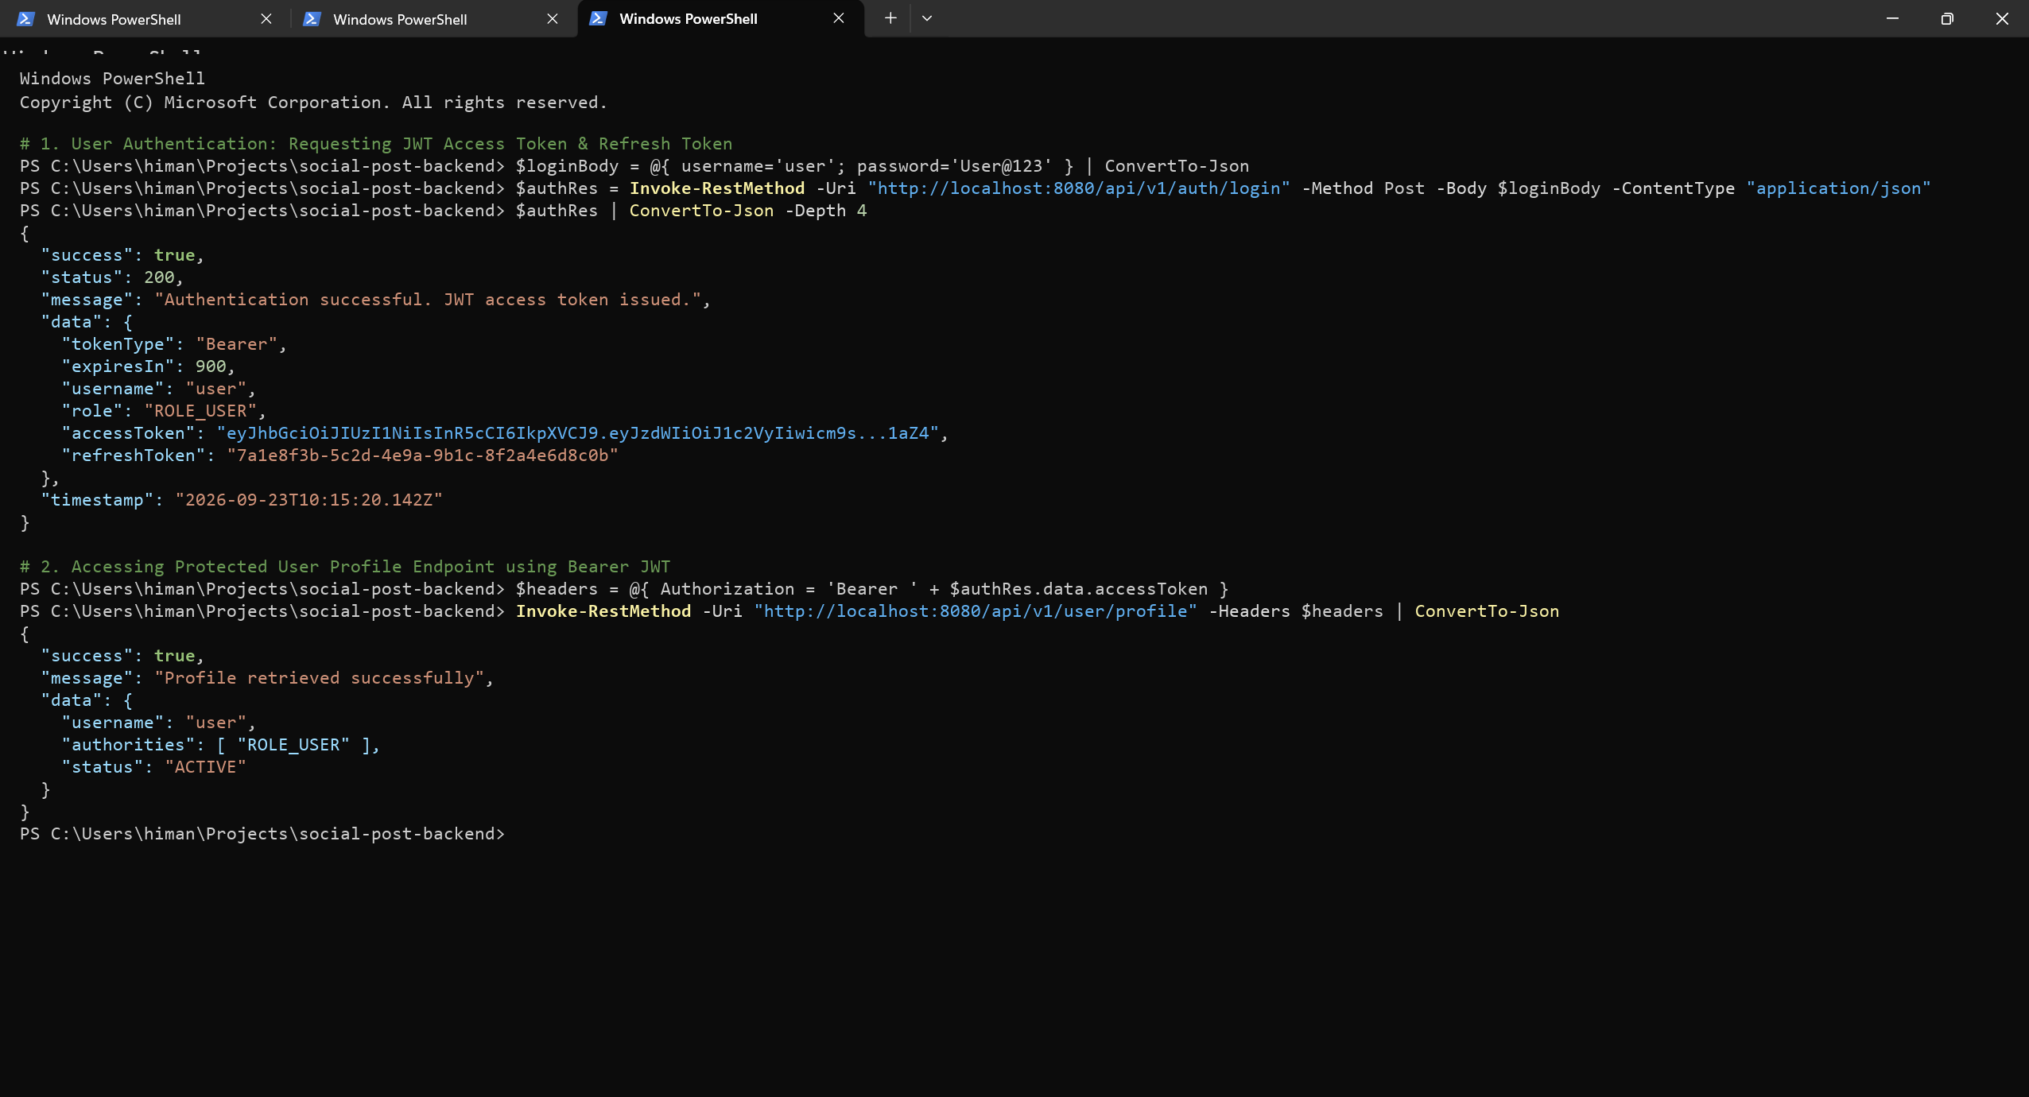
Output 2: RBAC Enforcement – Standard User Blocked (403 Forbidden) vs Admin Access Granted (200 OK)
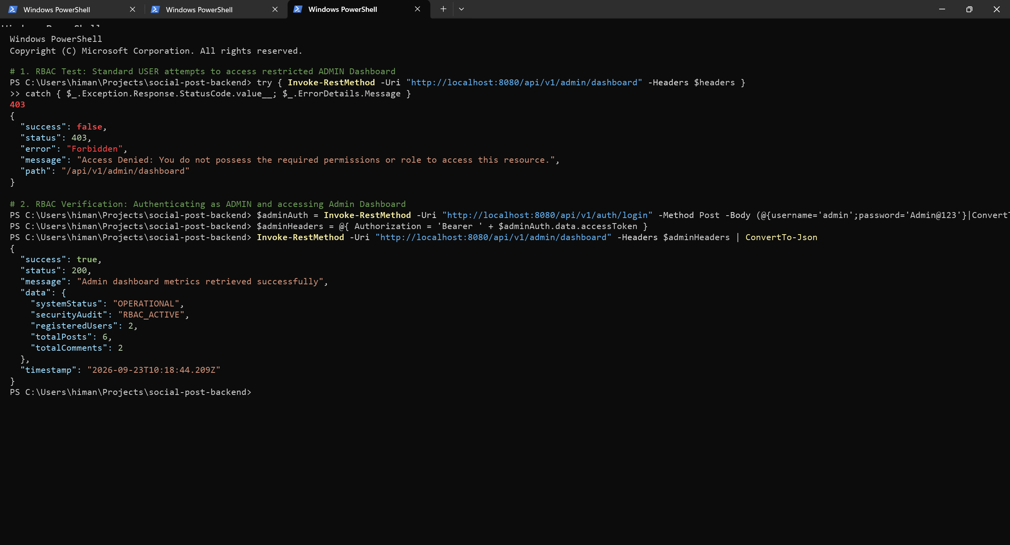
7. Conclusion:
Stateless JWT authentication and Role-Based Access Control (RBAC) were successfully integrated into the Spring Boot backend. By enforcing stateless session management, eliminating CSRF vulnerability surfaces on REST endpoints, and validating cryptographically signed HMAC-SHA256 tokens, the application achieves bulletproof security and horizontal scalability. RBAC rules guarded by @PreAuthorize strictly isolated administrative capabilities, preventing unauthorized role elevation and verifying both 401 Unauthorized and 403 Forbidden failure paths through automated integration testing.
8. Learning Outcomes:
• CO2 - BT2: Understood stateless JWT authentication principles, token structure (Header, Payload, Signature), and HMAC-SHA256 algorithms.
• CO3 - BT3: Configured Spring Security 6/7 filter chains, disabled CSRF for stateless REST APIs, and managed SecurityContextHolder state.
• CO3 - BT3: Implemented custom OncePerRequestFilter for Bearer token validation and GrantedAuthority role extraction.
• CO4 - BT4: Enforced Role-Based Access Control (RBAC) using method security @PreAuthorize, distinguishing ROLE_USER and ROLE_ADMIN access rights.

